1. So far we understood that to write a lambda expression, we need a function interface which helps compiler to know about   
   **NOTE**: Start from the method header from left to right and eventually return type.
   1. The return type.
   2. The access specifier.
   3. The method name.
   4. The # of parameters.
   5. The type of each parameter.
2. 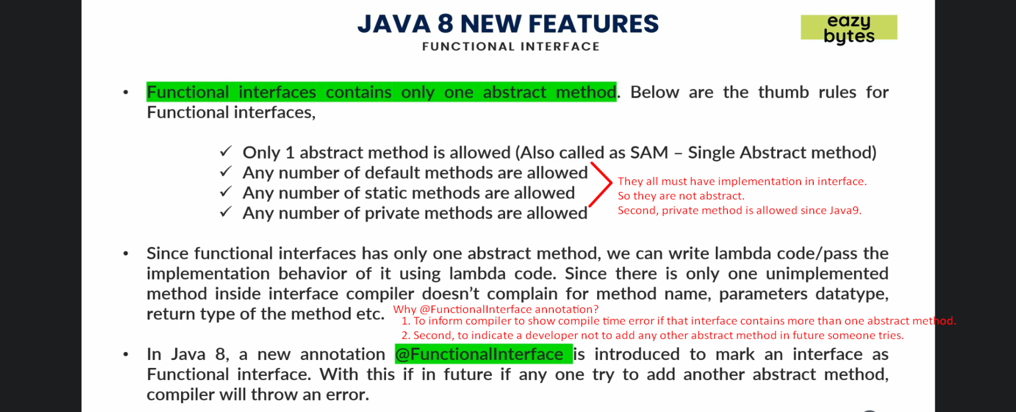
3. 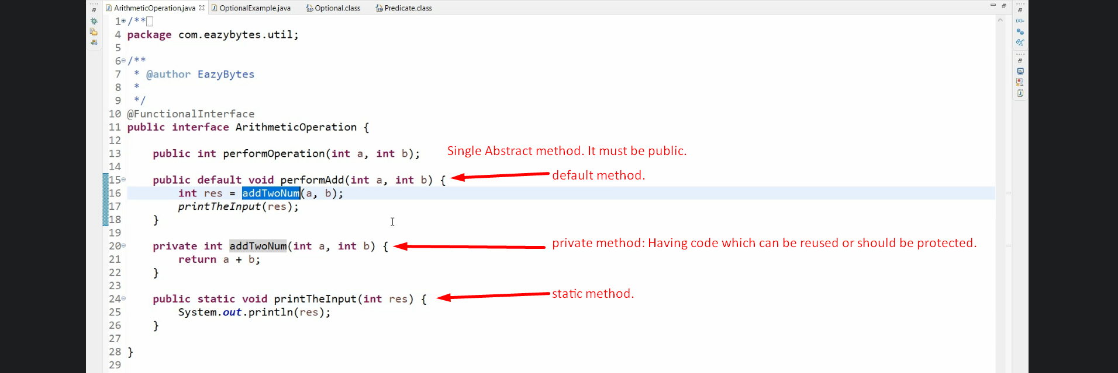
4. 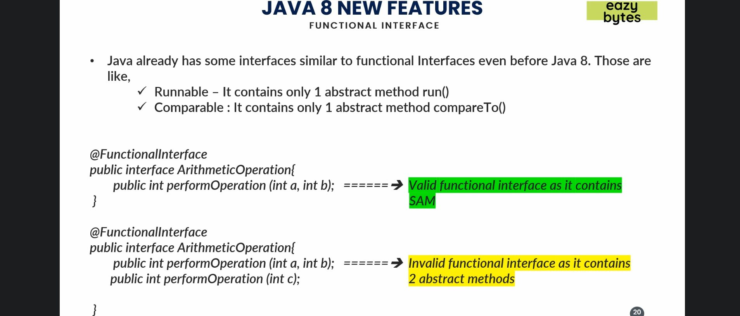
5. 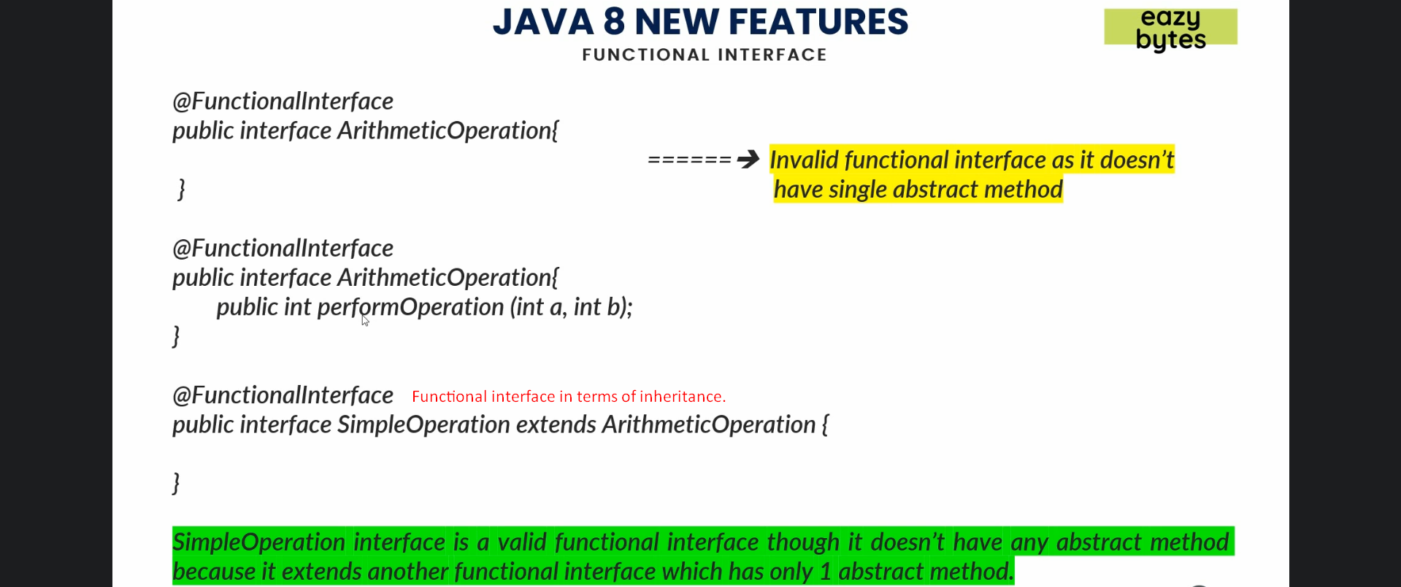
6. 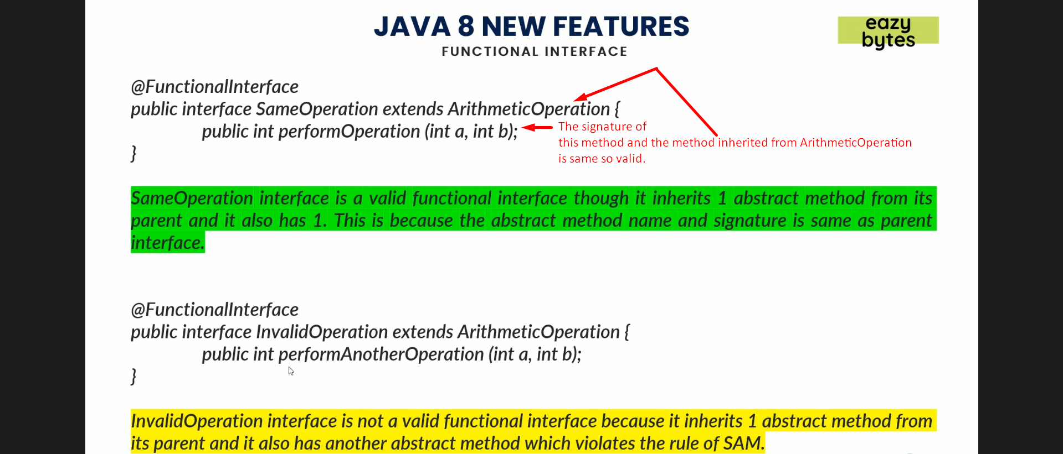
7. 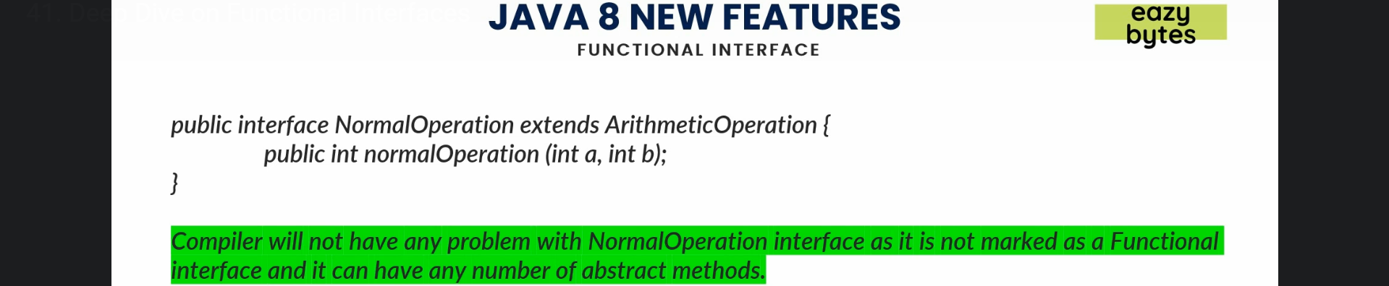
8. 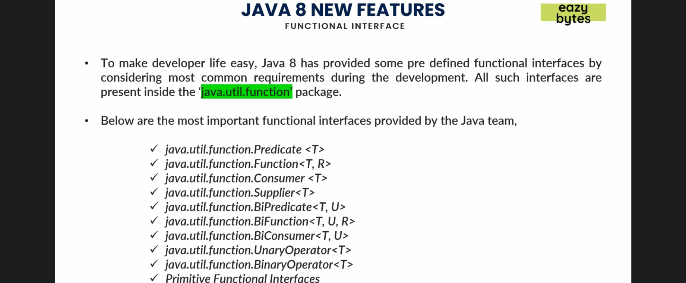
   1. In the upcoming lectures, we will see how to use them and in which scenario we can use them.